[LOGO OF THE SCHOOL]

WELCOME PACK FOR PUPILS AND PARENTS
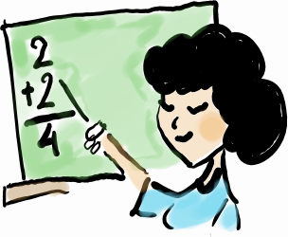



[NAME OF THE SCHOOL]
[ADDRESS]
[POSTCODE] Warsaw
[PHONE NUMBER]
[E-MAIL]
[SCHOOL WEBSITE]

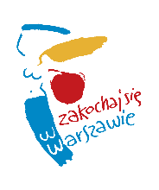

This booklet is based on The Welcome Pack for Pupils and Parents prepared as part of The Caerdydd-Warsaw Integration Project: Bridging the Education and Social Gap for Young People and Their Parents. The institutions which in 2009-2011 cooperated within this Comenius Regio Partnership included,
in Warsaw,
The Education Department of the City of Warsaw, Arteria Art Foundation, Janusz Korczak Primary School No. 211 with Integrated Classes and Leopold Staff Lower Secondary School No. 14 with Integrated Classes,
and in Cardiff,
Cardiff County Council, Race Equality First, St. Mary’s Catholic Primary School and Michaelston Community College.
The project’s objective was to provide foreign children and youth with support. The publication of this booklet has been possible thanks to co-funding received from the Comenius Regio Partnership Scheme of the Lifelong Learning Programme.

Authors: Anna Miastowska, Ewa Pawlic-Rafałowska, Katarzyna Rogalska, Monika Spurtacz, Małgorzata Zasuńska



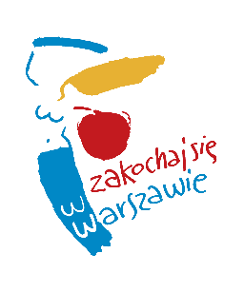

Dzień dobry! Cześć! Hej! – Hello! Hi! Hey!

Dear Pupil
Welcome to Warsaw and to your new school!
We are very pleased that you have come to join us, to live here, and that you are going to study and play in Warsaw. We hope that you will grow fond of Warsaw like those people arriving from foreign countries who have for many centuries helped this city grow. The multi-cultural Warsaw of today is proud that so many foreigners have made it their second home.
During the first days of your stay here, we will help you settle into your new school. You can always ask teachers and schoolmates around you for a helping hand and hints about anything you are not sure of. Please remember that we are here to answer all your questions and resolve your doubts.
We will be excited to listen to your stories about your family, friends, place you come from, and about your favourite dishes and music. This way we will get to know each other better.
“Fall in love with Warsaw” is our message to every one who arrives in our city and we wish it comes true for you very soon.

Joanna Gospodarczyk
Head of the Education Department
City of Warsaw

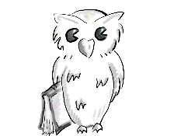

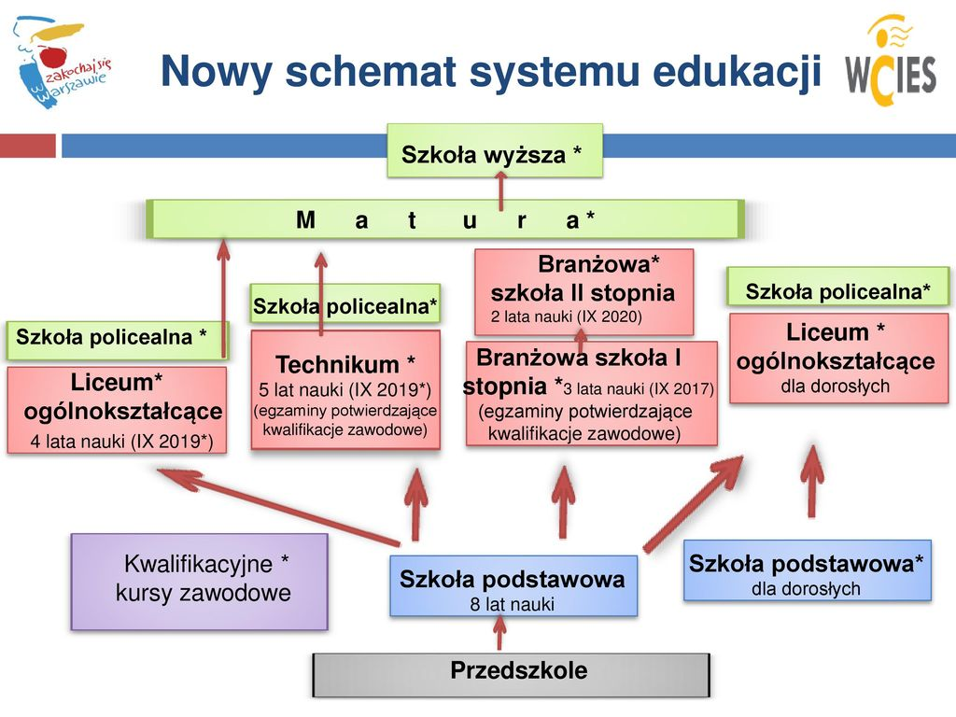
The New Reformed Levels of the Polish Education System

Higher education

Matura – post-secondary maturity exam

Post-secondary non-tertiary school

General upper secondary school 4 years (from Sep/2019)
Technical upper secondary school 5 years (from Sep/2019) (exams confirming vocational qualifications)
Stage I sectoral vocational school 3 years (from Sep/2017) (exams confirming vocational qualifications)
Stage II sectoral vocational school 2 years (from Sep/2020)
General upper secondary school for adults

Qualification vocational courses
Primary school 8 years
Primary school for adults

Preschool
First name:

Surname:

Class:

Form teacher:

Directions to school
[copy of your map here]

[NAME OF THE SCHOOL]
[ADDRESS]
[POSTCODE] Warsaw
[PHONE NUMBER]
[EMAIL]
[SCHOOL WEBSITE]

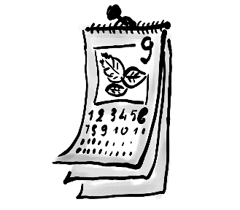
School year dates

MONTH | SCHOOL DATES & SCHOOL HOLIDAYS
September (9) | 1st September The beginning of the school year
October (10)
November (11) | 1st November All Saints' Day (holiday)  11th November Independence Day (holiday)
December (12) | 23rd December-1st January Christmas holidays  24th-26th December Christmas
January (1) | 1st January New Year's Day (holiday)  6th January Epiphany (holiday)
January (1) or February (2) | Winter holidays – 2 weeks (as decided by the Ministry of National Education)
March (3) | Easter holidays – 6 days (in March or April)
April (4)
May (5) | 1st May Labour Day (holiday)  3rd May May 3rd Constitution Day (holiday)
June (6) | The end of the school year (last week in June)
July (7) | Summer holidays
August (8) | Summer holidays

*The school will inform you about other school holidays.

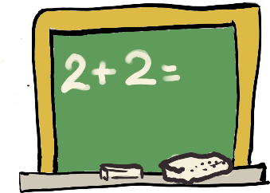
Bell times*
Lessons start at 8.00 every day
Time | Lesson/Break
8.00 – 8.45 | Lesson 1
8.45 – 8.55 | Break 1
8.55 – 9.40 | Lesson 2
9.40 – 9.55 | Packed lunch break
9.55 – 10.40 | Lesson 3
10.40 – 10.50 | Break 3
10.50 – 11.35 | Lesson 4
11.35 – 11. 55 | Hot meal lunch break  Years 1-3
11.55 – 12.40 | Lesson 5
12.40 – 13.00 | Hot meal lunch break  Years 4-8
13.00 – 13.45 | Lesson 6
13.45 – 13.50 | Break 6
13.50 – 14.35 | Lesson 7
14.35 – 14.40 | Break 7
14.40 – 15.25 | Lesson 8

Lessons end on Friday. We go back to school on Monday.
Note! Years 1-3 receive a detailed timetable from their form teacher.
* Please enter your current school timetable


Things you need at school

- books

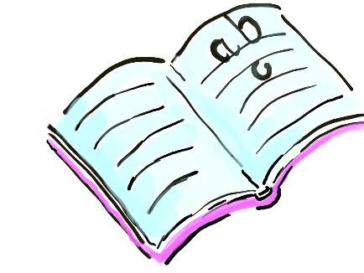
- workbooks


- a pencil

- scissors
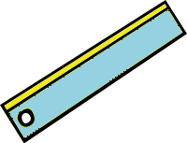

- a ruler
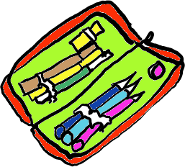
- a pencil case


- paints

- a sharpener
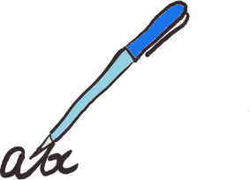
- a pen

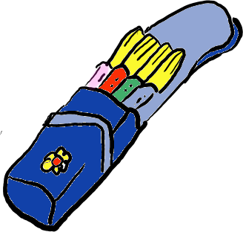
- crayons
- marker pens

Pupil's record book*

- You make notes about important school matters in your record book. 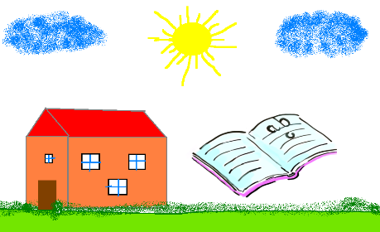

- In your record book, you can check your timetable every day.
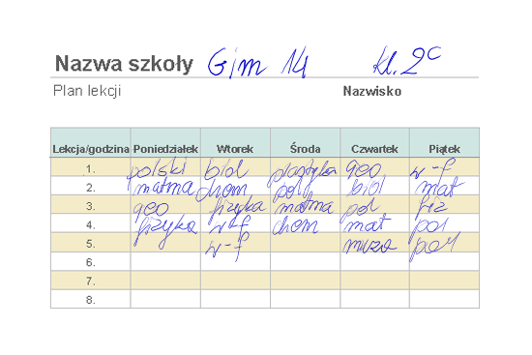

- Your parents will view it to read about important school dates (general parent meetings, parent consultation meetings, school excursions) and about your behaviour and progress).
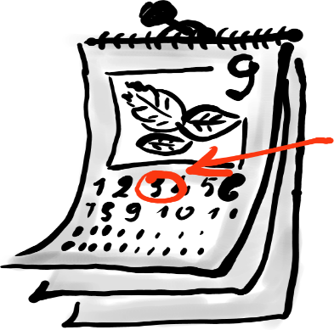

*If an electronic grade book or any other tool is used by your school to contact parents, please describe it in this section of the Welcome Pack.

Breaks

You must stay at school during breaks!

Places you can stay at during breaks:

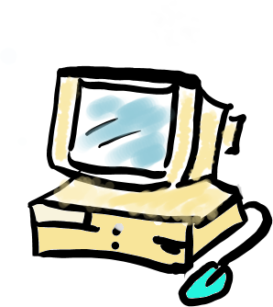
- library

- reading room

- school corridors (pupils in Years 4-8)
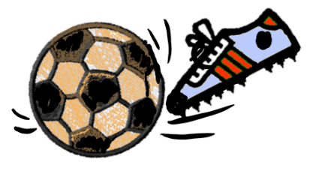
- school indoor sports hall – check the hours your class is allowed to spend breaks there

- school sports field – only under a teacher's supervision: in spring, summer and autumn.
- playground – under a teacher's supervision (pupils in Years 0/1-3; children staying in the after school childcare room)
- other (please specify other places where pupils are allowed to stay during breaks)
During the packed lunch break, you can eat your lunch in the classroom.
During the lunch break, you can eat a hot meal lunch in the school canteen.

To receive free school lunch, talk to a school counsellor/teacher.



Extra-curricular activities*

Extra-curricular activities for foreign pupils | - Extra Polish lessons (at least 2 hours a week)
Extra-curricular activities for foreign pupils | - Small group/one-to-one tuition (1 lesson a week of the subject a pupil has fallen behind in - taught for up to 12 months)
Extra-curricular activities for all pupils | - Subject-based clubs (you can choose from a range of subjects available)  - Clubs developing pupils' interests
Extra-curricular activities for all pupils | - Extra sports activities  - Library, computer labs
Extra-curricular activities for all pupils | - Activities in the common room
Extra-curricular activities for all pupils | - Small group/one-to-one tuition
Extra-curricular activities for all pupils | - Swimming

* Specify what extra-curricular activities your school provides.

What you do if:
YOU ARE ABSENT FROM CLASSES


Bring an absence/sick note from your parents or a doctor, and show it to your form teacher

YOU ARE LATE
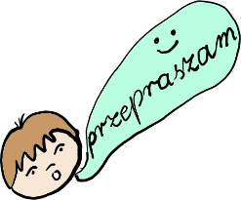

Go to your class and apologise for being late saying Przepraszam za spóźnienie

YOU ARE FEELING UNWELL
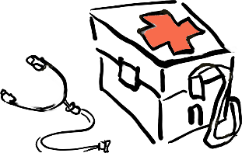

Talk to your form teacher or the school nurse. They will call your parents to pick you up from school.

YOU HAVE A PROBLEM
YOU HAVE A FIGHT WITH YOUR SCHOOLMATE | YOU CAN'T DO YOUR HOMEWOK BY YOURSELF
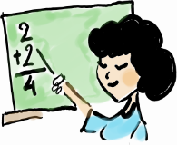
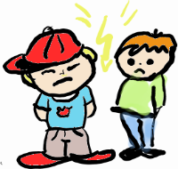

Talk to your form teacher or school counsellor. | Talk to your form teacher, other teacher or the school counsellor.

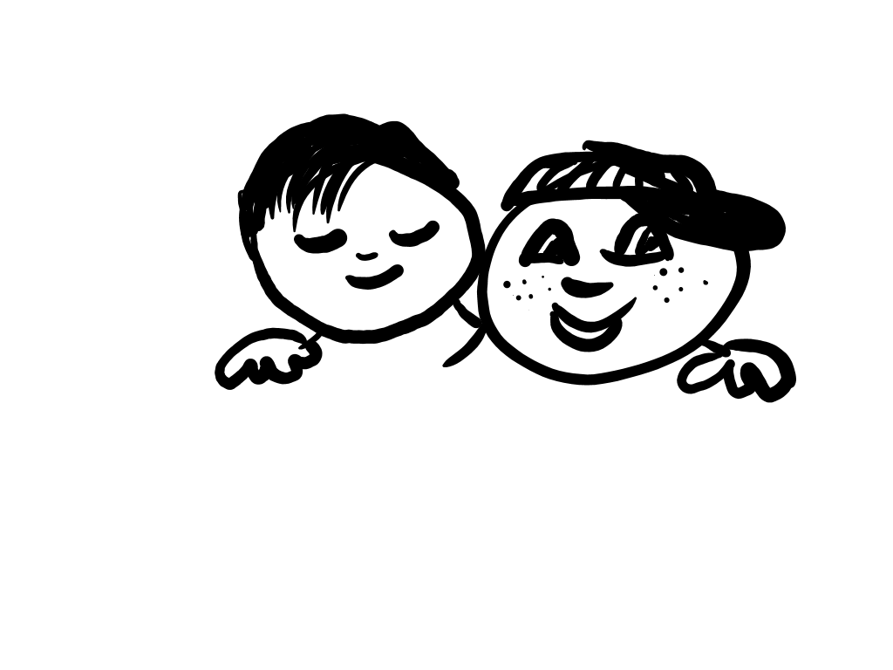
How to make friends with other pupils at school

- Your form teacher will introduce you to your new class.

- You will have plenty of time to find new friends.

- While some of your classmates may be more sociable, others are being shy, but this doesn’t mean they don’t want to be friends with you.

- We often admit new pupils to our school, so some schoolboys or schoolgirls you meet probably have been attending the school for as short as you have.



Assessment and grades

If you are a pupil of:

- Years 0/1-3

You and your parents get feedback about your learning progress and behaviour on an ongoing basis and at the end of each term.

- Years 4-8

- You are graded from 1 to 6
- Teachers grade your progress day-to-day
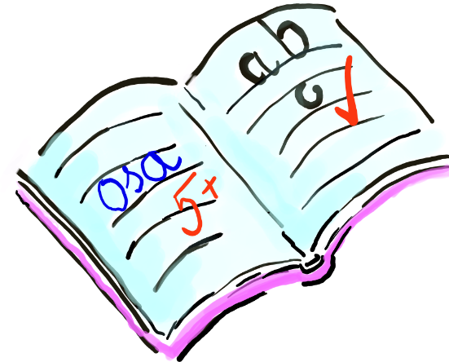
- At the end of each term and year, teachers give you final grades for every subject and for your behaviour

1 to 6 grading scale for subjects
6 – excellent (++++++)
5 – very good (+++++)
4 – good (++++)
3 – satisfactory (+++)
2 – poor (++)
1 – unsatisfactory (fail) (-)

Your behaviour will be graded as
- exemplary
- very good
- good
- acceptable
- unacceptable
- reprehensible

School forms templates

NOTIFICATION
The school head/form teacher would like to inform you that Class …………. general parent meeting will take place on (date) ……………………. at (time) …………………… in classroom …….…
Attendance is obligatory.

…………………………………..
School Head/Form teacher’s signature

ABSENCE NOTE

Please excuse my daughter/son,………………………….……………………………… ………………………. (name and surname) from school on ……………….. (date)
because of illness / medical examination / for other important family reasons.

…………………………………………
Parent's signature

EARLY LEAVE NOTE
Please release my daughter / son (name and surname) …………………….. ………………………………………..… from classes on (date) …………………………….at (time) …………………..

……………………………………….
Parent's signature

PARENT CONSENT
I consent to the participation of my daughter / son, …………………………..……………… (name and surname) in a school excursion / integrating journey / school residential trip to …………………………… (destination) on …………………………… (date)

……………………………………….

Parent's signature

Glossary of basic school terms
PL | RUS. | UKR. | CHECH. | VIET. | ENG. | ARAB.
Rok szkolny  W Polsce nauka rozpoczyna się 1 września, a kończy w ostatnim tygodniu czerwca następnego roku. | . |  |  |  | School year  In Poland school starts on 1st September and ends in last week of June the following year.
Semestr  To połowa roku nauki: semestr zimowy trwa zazwyczaj od września do końca stycznia, semestr letni – od lutego do czerwca. |  |  |  |  | Term  means a half of the school year: typically, the winter term lasts from September until the end of January, the summer term lasts from February until June.
Przerwa semestralna  Po pierwszym semestrze uczniowie w Polsce mają dwutygodniową przerwę w nauce – ferie zimowe. |  |  |  |  | Term break  After the winter term, schools in Poland close for a two-week break, called the winter holidays
Wakacje  To czas wolny od nauki w ciągu lata. Trwa od ostatniego tygodnia czerwca do końca sierpnia. |  |  |  |  | Summer Holidays  Schools close for the summer, from the last week of June through August.
Wywiadówka  To spotkanie rodziców z nauczycielem/nauczycielami ucznia. Jego celem jest omówienie postępów dzieci w nauce oraz innych ważnych spraw dotyczących życia szkoły. |  |  |  |  | Parent consultation meeting  means a time when parents meet with their children’s teachers to talk about the pupil's progress and other important school matters.
Ocena  Począwszy od czwartej klasy szkoły podstawowej uczniowie są oceniani przy pomocy skali od 1 do 6. 6 to ocena najwyższa. 1 to ocena najniższa. Od ucznia oczekuje się opanowania materiału co najmniej na 2. |  |  |  |  | Grade  From Year 4 of the primary school onwards pupils get grades 6 (best) to 1 (worst). Pupils need to reach the level of grade 2 to pass.
Biblioteka  Miejsce, gdzie uczeń może na miejscu, bezpłatnie skorzystać ze szkolnych zbiorów książek. Może też wypożyczać książki do domu. |  |  |  |  | School Library  means a room where pupils can read all books from the school library collection free of charge. The books can also be borrowed and taken home.
Dyrektor szkoły  Osoba, która kieruje szkołą. |  |  |  |  | Head teacher  means a person who manages the school.
Pedagog szkolny  Specjalista pomagający dzieciom, które mają trudności szkolne. |  |  |  |  | School counsellor  is a professional who helps children experiencing difficulties at school.
Psycholog szkolny  Specjalista, który pomaga uczniom radzić sobie z trudnymi emocjami i uczuciami. |  |  |  |  | School psychologist  A professional who helps pupils cope with difficult emotions and feelings.
Poradnia psychologiczno-pedagogiczna  To miejsce, gdzie specjaliści badają dzieci pod kątem ich możliwości korzystania z edukacji. Pomagają dzieciom, które napotykają bariery w edukacji. |  |  |  |  | Psychological and educational centre (guidance and counselling body)  means an institution where specialists examine children’s educational capabilities and help those who face any educational difficulties.
Nieobecność  W Polsce dzieci mają obowiązek chodzić do szkoły, dopóki nie skończą szkoły podstawowej. Jeśli dziecko nie przyjdzie jakiegoś dnia do szkoły, rodzice są zobowiązani napisać ‘usprawiedliwienie’, czyli wyjaśnić, dlaczego dziecko nie przyszło do szkoły. W przypadku dłuższych nieobecności wywołanych kłopotami ze zdrowiem szkoła oczekuje zwolnienia lekarskiego, czyli dokumentu od lekarza, który potwierdza, że dziecko było chore, co uniemożliwiło mu przybycie do szkoły. |  |  |  |  | Absence  In Poland, attending school at the primary school level is obligatory. If a student is absent from school, his/her parents must write an absence note, in which they provide the reason of the absence. In the event of pupil’s longer absence due to illness, the school requires a sick note, which is a certificate written by a doctor to confirm the child missed classes due to illness.
Egzamin  Już na koniec szkoły podstawowej uczniowie zdają egzamin – czyli sprawdzian zewnętrzny, badający poziom wiedzy i umiejętności zdobytych w szkole. |  |  |  |  | Exam  Primary school pupils in Poland sit the final exam, which is an external test of their knowledge and skills acquired at school.
Długa przerwa/przerwa obiadowa  To dłuższa przerwa w godzinach południowych (około 20 minut), w czasie której dzieci mają czas zjeść posiłek. W niektórych szkołach w Polsce są stołówki, gdzie dzieci mogą zjeść obiad. Gdy nie ma stołówki – jedzą przyniesione z domu kanapki. |  |  |  |  | Long break/hot meal lunch break  means a longer break around noon (lasting about 20 minutes), when children can eat lunch. Some schools in Poland run school canteens where children can eat a hot meal. If there is no school canteen, they eat their packed lunch.
Przerwa  To czas krótkiego odpoczynku dla uczniów między lekcjami, zwykle trwa 10 minut. Lekcje trwają 45 minut. | . |  |  |  | Break  means a short rest time between lessons, typically lasting about 10 minutes long. Each lesson lasts 45 min
Grono pedagogiczne  To zespół nauczycieli uczących w danej szkole. |  |  |  |  | Teaching staff  All the teachers working with the school.
Pokój nauczycielski To specjalna sala w szkole przeznaczona dla nauczycieli. Tam można znaleźć nauczycieli w czasie przerw. |  |  |  |  | Staff room  means a special room provided specifically for teachers, where you can find teachers during breaks.

